Volleyball Simulation Game Design Document

* this is a living document, design subject to change

General Summary

Currently untitled volleyball simulation game is a strategy simulation game where players take turns moving their players in sequence with volleyball rallies and compete to win a match. In our final iteration of the game we will have a single player competing against an AI controlled opponent. There may be potential for a player versus player mode also.

Rally Flow:

Serve

Pass

Set

Attack

Defence

Pass

Set

Attack

Defence

And so on…

Possible Rally Outcomes:

Each rally has a finite set of outcomes. They are as follows:

**Ace** -> the serving player directly scores a point on the serve / passer is not successful in making a pass

**Service Error** -> the serving player makes an error and a point is awarded to the opposite team

**Attack Error** -> after receiving a set, the attacking player hits out of bounds or into the net, awarding a point to the opposing team

**Block** -> the blocking player is able to stop the attack and scores a point

**Tool** -> the attacking player hits the ball off of the blocking player to score a point

**Kill** -> the attack is successful, the attacking player hits the ball past the block, and the defending player is unable to make a dig

Rally Flow (With Outcomes)

Below is a detailed flow of a rally with its potential outcomes:

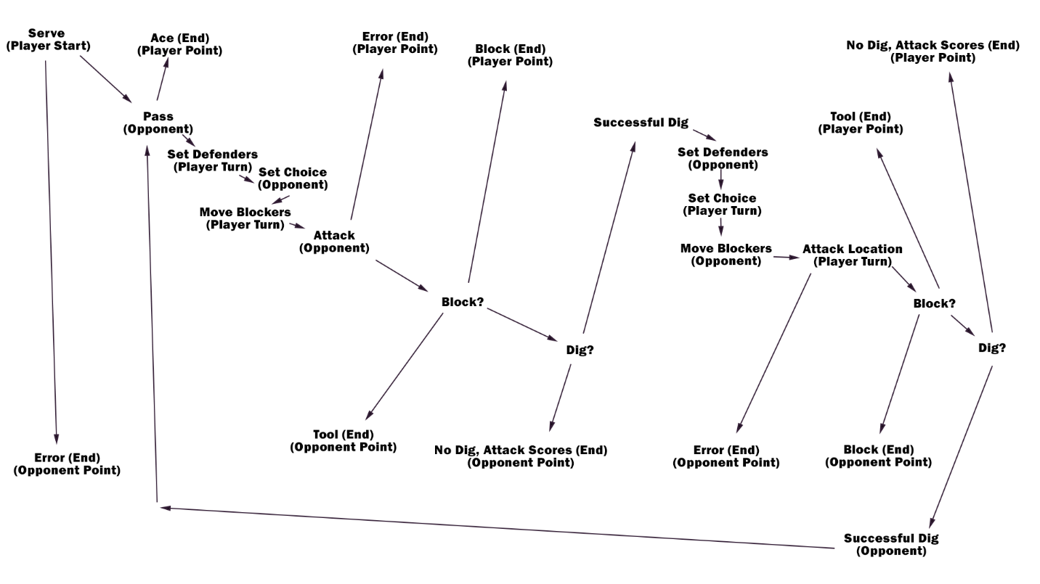

Serve

Player chooses a location on the court to serve. A service quality number is generated based on that players skill level. The service quality will effect the location that the serve actually goes to. A good quality serve goes exactly where the player had chosen, and a poor quality serve will randomly end up somewhere away from the chosen location.

- If the serve is very low quality, it becomes a service error and the rally ends

Pass

The passing player moves to a position as close as possible to the serve location. Based on the players distance from the ball, the passing player’s passing skill and a randomly generated number, a passing quality number is generated. The possible passing quality numbers are as follows:

- 0 -> a zero pass, the passing player is unable to make a successful pass, the serve is counted as an ace and the rally ends  
- 1 -> a one pass, the pass is poor and makes the set more difficult for the setter to make. A one pass also limits the available attackers to only one front row player and one back row player

- 2 -> a two pass, the pass is ok and only makes the set slightly more difficult to make. A two pass does not allow for the middle attacker to be used, but all other hitters are available.

- 3 -> a three pass. The pass is high quality, making the set is much easier and all hitters are available

Below is a diagram of the areas on the court used by the serve and pass as an example and to illustrate where the locations on the court each contact will take place.

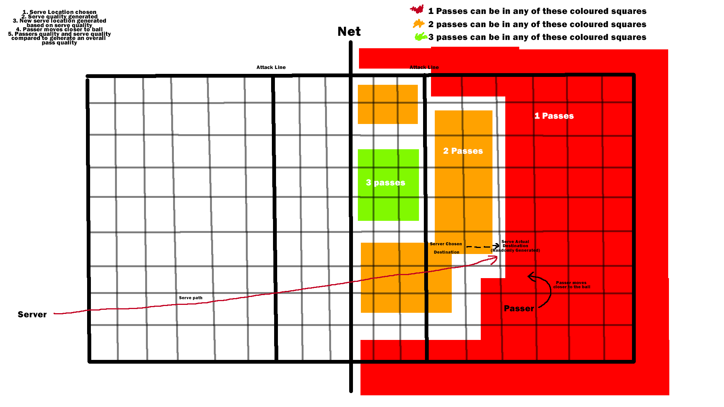

Move Attackers

The team who just passed has an opportunity to move their attackers into a position to attack. They may move their players to any position on the court.

Move Defenders

The defending team has a chance to set up their defenders wherever on the court they would like. Any blockers must be placed in the row closest to the net.

Set Choice

The team who just passed will now have an opportunity to choose who they will set. The setter automatically moves to the location of the pass. The setters options are limited by the quality of the pass. The player makes a set selection from one of their available options. Each player on the court can be an option to attack, including back row players.

React Defenders

The serving team now has an opportunity to move their blockers and defenders in response to their opponents set selection. The blockers and defenders are are only able to move a certain number of squares during this time. To start we can say they can only move one square.

Attack

The attacking player now selects where on the court they would like to attack. They can select any square on the opponents grid. After selection an attack quality is generated based on the set quality and the attacking players skill.

- If the attack quality is very poor, it is considered an error and the opponent is awarded a point

Block

Using the number of blockers in the area around the attacker a random number is generated that determines if the attack makes contact with the block. Ideally, the trajectory of the attack is also considered when calculating this block contact number (if the trajectory goes right through the blockers position, there is a boost to block chance. If the trajectory avoids blockers, there is a boost to attack success chance). One of two outcomes is determined:

- if the ball does not contact the block, progress to the defence stage  
- if the ball does contact the block, continue with block stage

If the ball contacts the block, a block quality is calculated based on the number of blockers in the vicinity of the attacking player and the blocking players skill. Ideally, the trajectory of the attack is also considered when calculating this block quality number (if the trajectory goes right through the blockers position, there is a boost to block chance. If the trajectory avoids blockers, there is a boost to tool success chance). The block quality is compared to the attack quality and a result is determined.

- If the attack is stronger than the block, the result is a tool and a point is awarded to the attacker, rally ends  
- if the block is stronger than the attack, the result is a block, rally ends and a point is awarded to the defender

Defence

Using the nearest defenders proximity to the attack location and the defenders skill a defence quality number is generated. Ideally the trajectory of the ball is considered in this calculation also (if the ball passes through or near the defenders location, there is a boost to their success chance) This defence number is compared to the attack number to determine one of two outcomes.

- The attack quality is better than the defence quality, the rally ends and the attacker scores a point

- the defence quality is better than the attack quality, the rally continues, teams switch roles. This defence step is treated the same as the passing step and a pass quality number is generated using the attack quality and the defence quality. The pass quality is then passed to the set stage and the sequence repeats.

The sequence repeats until there is a rally ending outcome. Below are images that illustrate the various steps:

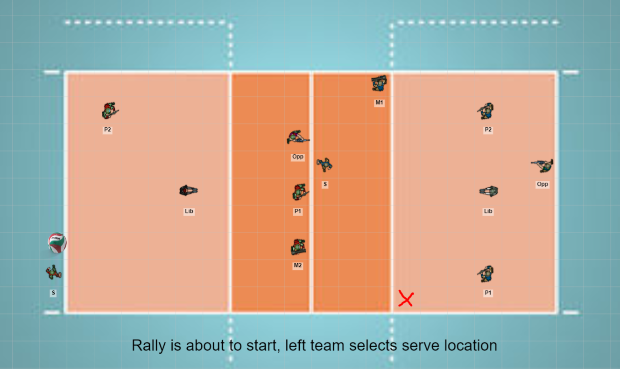

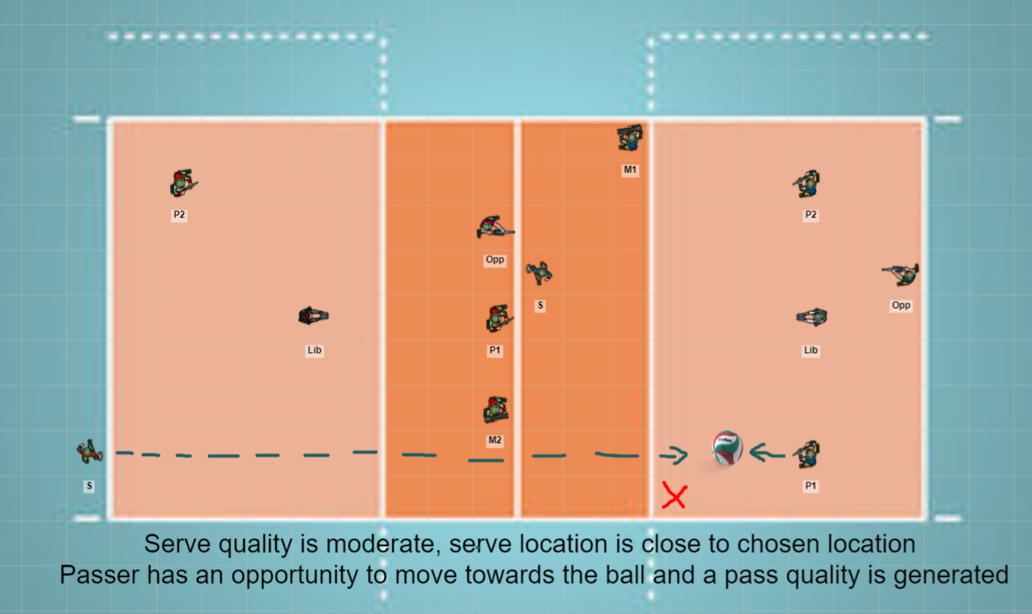

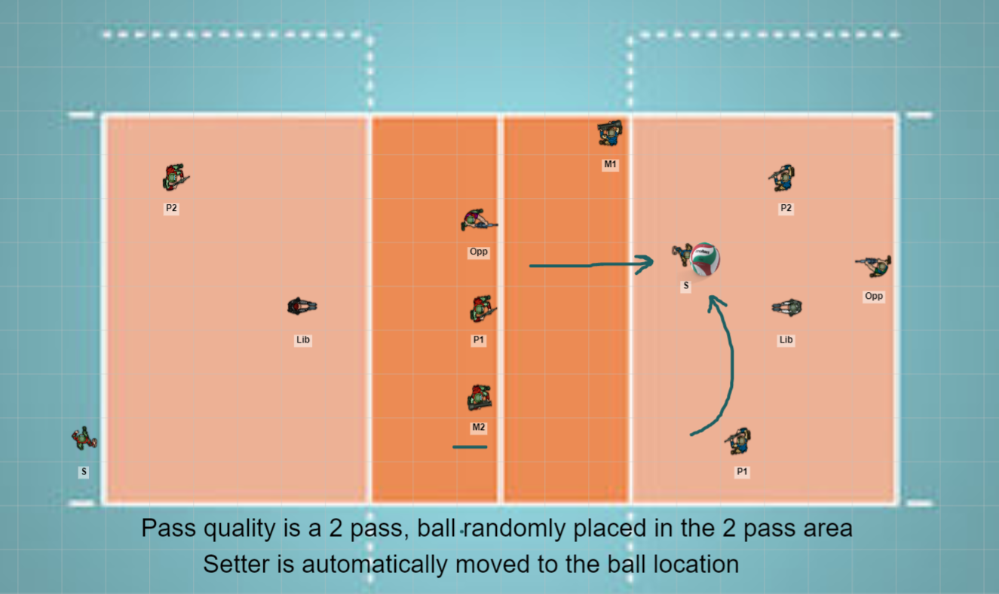

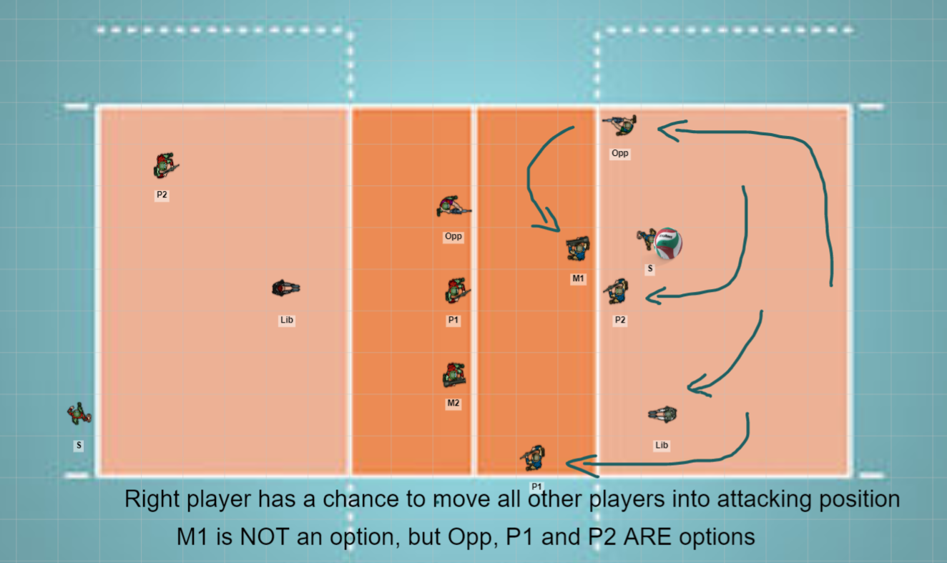

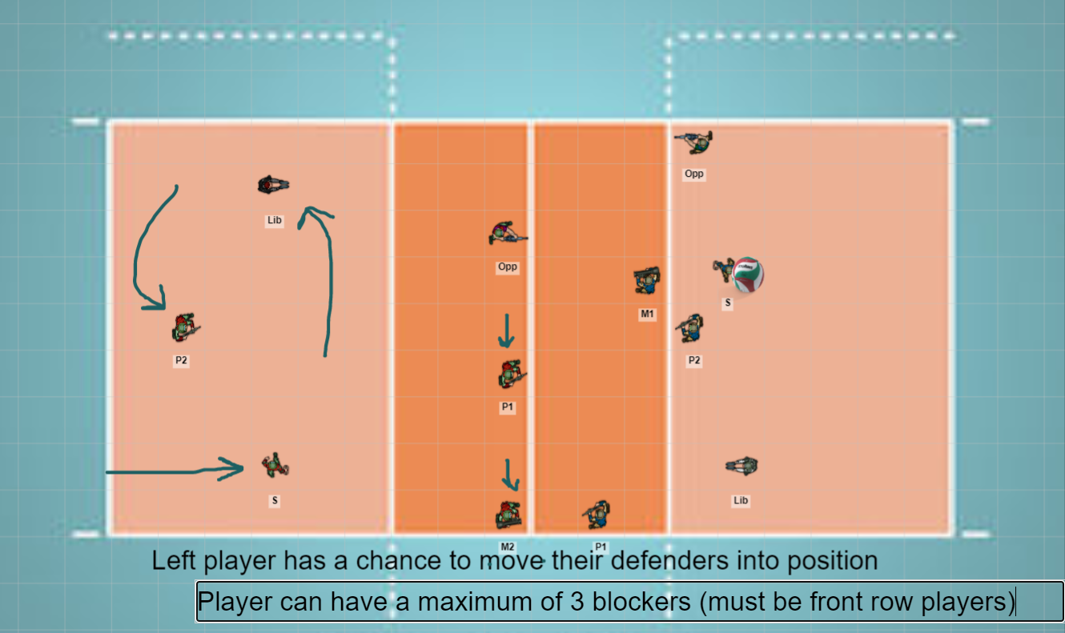

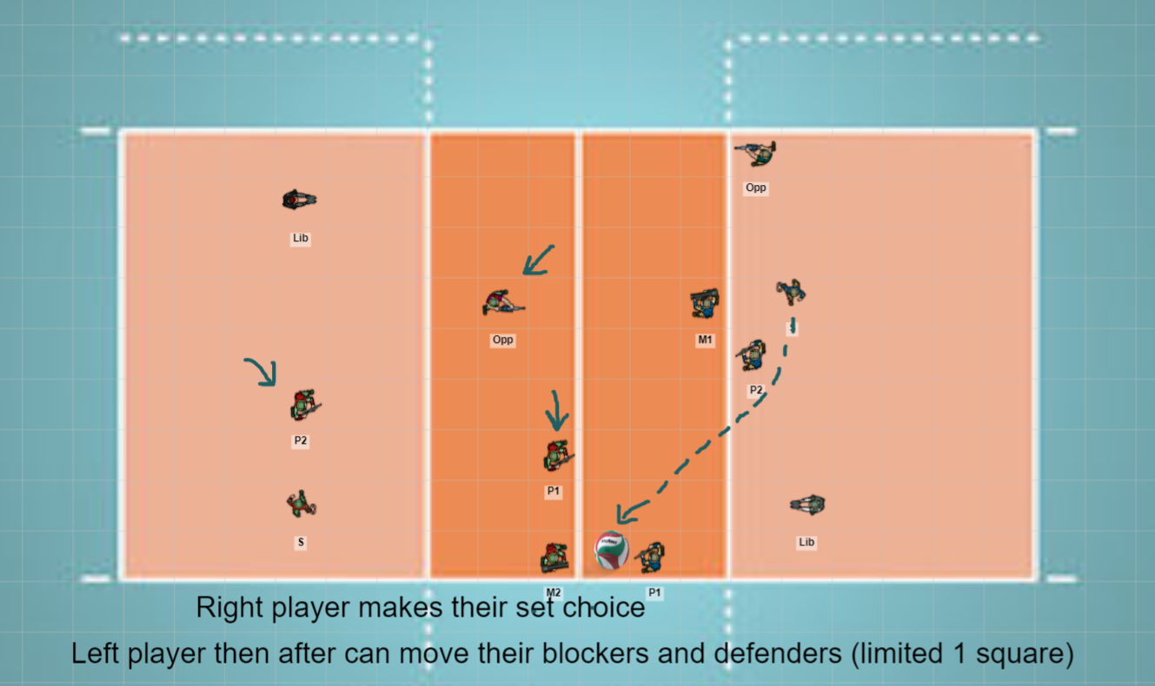

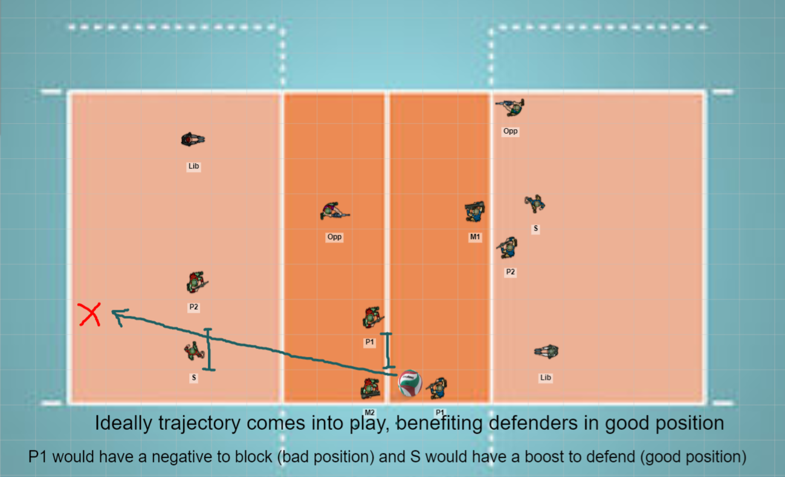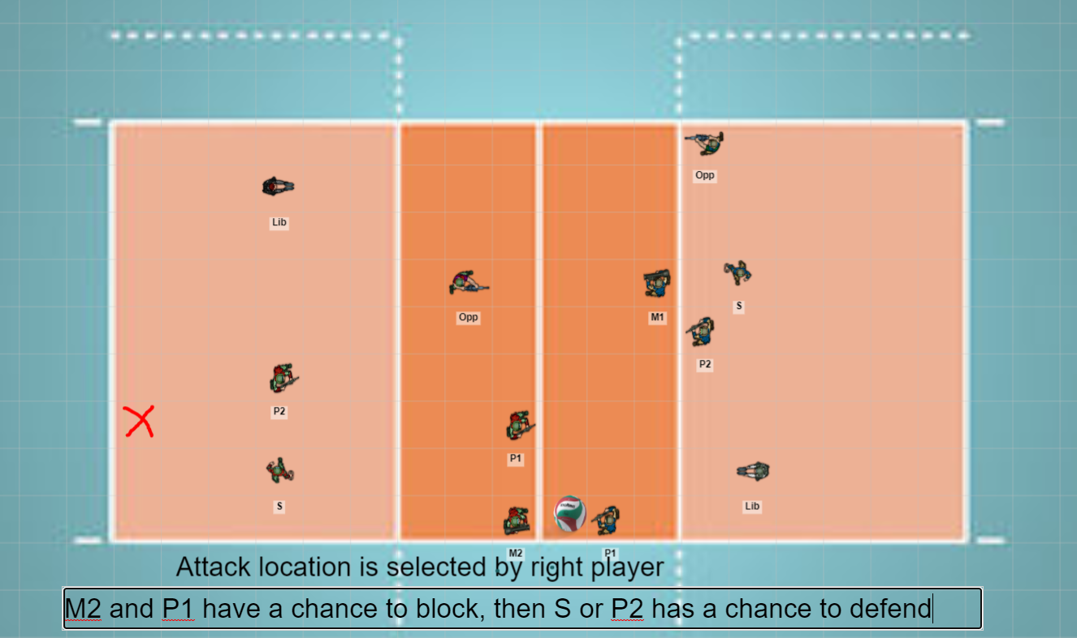

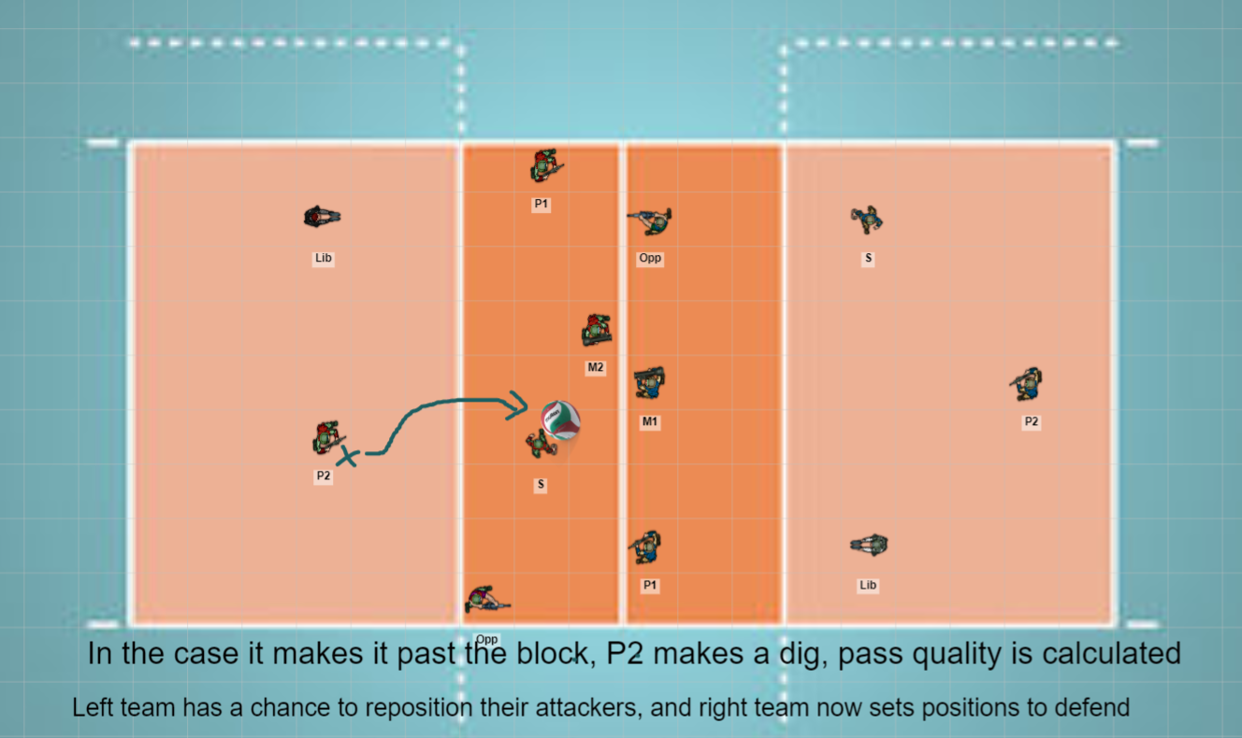

Game Mechanics

The player only interacts with the game during certain steps of the rally and makes choices and movements for their team. These player actions are as follows (Black = MUST, Blue = LIKE to have):

Pre rally player location movement

Serve Location Selection

Passer movement

Attacker Movement

Set Selection

Attack Location Selection

Defenders Movement

Blocker/Defender Reaction

Pre Rally Player Location Movement

Before the serve is made, the receiving team is able to place their players on the court wherever they would like to try to cover the court. Players must be in the proper rotational lineup otherwise the rally cannot begin. Player can move their teams players by clicking and holding the left mouse button, moving the mouse to the tile that they want the player to be in, and letting go of the left mouse button. Players will snap to the nearest tile centre that they are left at. Only one player can be in a tile at a time, and a player must be in a single tile, never multiple. A UI button signals that the player is satisfied with their movements.

Serve Location Selection

The player clicks on the tile on the grid that they would like to attempt to serve towards

Passer Movement

When the actual serve location is determine by the random generation. The player can elect which of their passers to move towards the ball and attempt to make a pass. During this time the number of tiles a player can move is limited. For now the movement speed is 2 tiles. The player moves their teams passer by clicking with the left mouse button and dragging to a new tile, letting go snaps the passer to the closest eligible tile. (This could be done automatically, without the players input, probably less fun)

Attacker Movement

The player is able to move all players except the setter to any tile on the court. For players to be eligible to be attackers they must be in one of the four rows closest to the net. A UI button signals that the player is satisfied with their movements.

Set Selection

Some indication of the available options is presented to the player. Potentially UI buttons on screen above or below the attackers heads, that the player can click to select that attacker to set.

Attack Location Selection

The attacking player can click any tile on the opponents side of the court to choose to attack the ball there.

Defenders Movement

The player can move their defenders to any tile on their side of the court. Clicking and dragging to move them, the players snap into the nearest tile when left click is released. For blockers to be eligible to block they must be in the row closest to the net. A UI button signals that the player is satisfied with their movements.

Blocker/Defender Reaction

The player can move their defenders a maximum of one square away from their starting location when this phase is entered. All six players can me moved if desired. A UI button signals that the player is satisfied with their movements.